Reasonable Care

(HealthCare Management System)

CSC 540 Database Management Concepts and Systems

Project Report #1

Project Team

Amit Borulkar aborulk@ncsu.edu
Pushpendra Gupta pgupta6@ncsu.edu
Satvik Andi sandi@ncsu.edu
Yogesh Birla ydbirla@ncsu.edu

1) Assumptions and Problem Statement

Assumptions

We have considered the following assumptions to be true while making the design choices of our system.

- A Student, will, by default be enrolled into Acme health insurance on registration.
- The student status will be changed to HOLD if he does not take the required 3 vaccines. The other department will directly check the student record to see if the student status is active or not.
- The first physical is always the free one.
- When a student calls the receptionist for an appointment, the receptionist uses the same application interface for booking as the student.
- Doctor is only responsible for all medication. Nurse only offers medical advice.
- The co-payment amount is the amount that the student has to pay in the total bill (20%). The rest of the bill (80%) is directly billed to the insurance when the appointment is confirmed.
- When a student has paid the minimum deductible then he does not have to pay even the co-payment.
- The appointment duration will be fixed (20 minutes only).
- All health insurance will provide cover in 20:80 ratio.
- Student already has student ID given by the university before they access the system. Student ID will be the login ID and student Date of Birth will be the default password for students.
- Availability entity set contains information about the availability of employees. This entity set is populated by the HR department that handles the employee shifts and leaves. Our system will only access it for checking the availability. (It will be a read-only table).

Problem Statement

We need to build a reliable, robust and non-redundant database system for Reasonable Care, a Health Care Center for a University. This database system will be used by students of the university, the doctors, nurses and the receptionists of the reasonable care center. Information like student enrollment, appointments with doctors, medical records, vaccinations taken and student privileges are maintained in the system. Each student is enrolled into the ACME health insurance plan by default.
Nurses and Receptionists both will help the students book appointments with the doctor. If the nurse is able to advise the student, there would be no need of an appointment. Else, a doctor is chosen according to his speciality, availability and the student’s health problem. Each appointment has billing associated with it as per insurance threshold value after which the student’s insurance will cover all the expenses at the center. Also, a student can cancel his appointment in advance of the date.
Doctors have access to, and can also update students’ records. System maintains the information of physical checkups of the student. Student is allowed to opt out of the default health insurance of the university.
The basic operations to handle are managing (creation, updating and deletion) of a user (Student, Doctor, Nurse, Receptionist) accounts. Managing appointments made by students (in present and future dates) with appropriate specialists. The system is built to bill the student until he pays insurance coverage minimal amount and later charges only the insurance company. Doctor updates the system after the appointment. Nurses also update the system with advice given to the students on the hotline call.

Advantages of using a database as opposed to files for this task:
- Searching, Updating and Deletion of records is more efficiently done in database rather than on multiple set of files.
- Multiple users can access the database concurrently for accessing records but this is difficult with a set of files, and on updating, can lead to unstable records in the system.
- Complicated queries can be run on databases to access specific data from the database which is very difficult with files.
- Redundant information can be avoided in the database system which is more probable when we store data in files.
- Unique Primary key constraints cannot be pushed onto files as in the database system.
- Database Systems perform better in the network where multiple users access the same system from multiple places in the network.
- Database manipulation by maintaining the normalization rules can be done more efficiently in a database system.
- It becomes difficult to achieve database normalization and non-redundancy in information with the data stored in multiple files.
- Concepts of Joins which make data storage more manageable are not applicable on files.

2) User Classes

Reasonable Care is a health care management system for a university. The following are its actors:-

1) Student: A student is the primary beneficiary of this university health care system. A student:

- Should have ACME (or) third party health insurance without fail.
- Calls ReasonableCare health center to book and cancel appointments for check-up or vaccination.
- Describes health problem to nurse using same-day-care hotline in non-emergency situations and requests medical help.
- Retains dining, housing and library privileges by ensuring that (s)he takes the three required vaccines before the end of the first semester.

2) Doctors:
- Treat students for illness, prescribe medication and administer vaccines.
- Update student records after every visit.

3) Receptionists:
- Receives student requests for appointments, checks with doctor’s schedules and fixes date and time accordingly.
- Asks students for which doctor they intend to visit, whether it is their first appointment and what their health problem is.
- Chooses specialist based on the student’s health problem.

4) Nurse:
- Answers student illness queries on helpline and advises medication.
- Accesses the list of previous visits to find out which doctor to call for advice about the student.

5) System Administrator:
- Enrolls all students and health center and provides them with a default password giving them access to update their information later.
- Can add and delete student or employee and update any of their information.

3) Five Main Things
The following are the important aspects of the Reasonable health care regarding which information should be maintained:
- Student: All the information of the student like Name, Date of Birth, student id(primary key), email, emergency contact, Phone Number, Status(active/ On hold).
- Employee: Employee's basic information Employee ID (primary key), Social security number, phone number, employee's schedule.
- Health Insurance: The basic information regarding health insurance like insurance id (primary key), Deductible amount, name, coverage costs etc.
- Doctors: The basic information Name, ID, Specialization and charges
- Appointments: It acts as a central entity like start time, end time, date, notes, purpose, amount paid by student, amount paid by insurance company, the notes maintained by the doctor (medical history) etc.

4) Pragmatic Situations

- Making an Appointment.
A student calls the health center for an appointment. The receptionist will take the student ID and look for student records. Then she will suggest his/her past doctor. If the past doctor is not available, she will suggest other doctors and book the appointment accordingly.
Operations: Viewing Student records, choosing a doctor, checking student insurance.

- Billing the student.
The student provides his credit card details to the system/receptionist. The system deducts the co-payment amount from his card and confirms the appointment. On appointment day, the receptionist checks the student record and charges him according to the insurance plan.
Operations: Viewing student record, checking student insurance plan, validating full deductible amount.

5) Application Program Interfaces

Manage User Account
registerNewStudent (StudentId,SSN,Name,Age,Sex,Email,InsuranceID,EContact)
return {
Registration Confirmation
or
NULL if(record duplicate or Incorrect Information)}
}
recordStudentInsuranceInfo(InsuranceId,StudentId,ExpiryData,DeductibleAmt)
return {
SUCCESS(Information saved in health center database)
Or
NULL if (error in input parameters)
}

updateStudentInfo(StudentId,SSN,Name,Age,Sex,Email,HInsurance,Econtact)
return {
UPDATE Information (Information updated in database)
or
ERROR if (Incorrect Information)
}

logInTheSystem (StudentId/EmployeeId,Password)
return {
(if StudentID) studentInterface
else if (EmployeeID) employeeInterface
else if (Incorrect Information) Error
}

Make Or Cancel Appointment
makeAppointment (studentId,purpose,doctorName,date,creditInfoForCoPayment)
return{
if(SUCCESS)
doctorInfo, appointmentSchedule, appointmentConfirmation
else
Appropriate Error or NULL
}

cancelAppointment (studentId, doctorName, date)
return{
if (SUCCESS)
copayment refunded, appointment Cancelled, appointment Cancel Confirmation
else
Appropriate Error or NULL
}
viewAppointment(date,employeeId,studentId)
return{
if(SUCCESS)
appointmentListForDate
else
ERROR OR NULL
}

updateAppointment(date,appointmentId,studentId/recorded,newAppointmentDetails)
return{
if(SUCCESS){
New Appointment Confirmation,Database Updated)
else
Error or NULL( OLD Appointment persists)
}

Staff Interface
updateEmployeeRecord(updatedEmployeeInformation)
return{
if(SUCCESS)
updateEmployee record in database
else
NULL OR ERROR
}

viewVaccinesTaken(studentId)
return{
if(SUCCESS)
vaccination Information
else
NULL or ERROR
}

Handle Billing and copayment
billStudentForAppointment(studentId,insuranceId,creditCardInfo){
return{
if(SUCCESS)
billing and Appointment Confirmation
else.
ERROR OR NULL( if inputDetails not valid)
}

viewStudentRecords(studentId)
return{
if(SUCCESS)
studentPersonalInfo,studentVaccineInfo,studentMedicalHistory
else
ERROR OR NULL( if wrong studentID)
}

addNotes(doctorNotes,nurseConsultationNotes)
return{
if(SUCCESS)
(Doctor/Nurse) notes saved
else
ERROR OR NULL
}

viewDoctorInfo(doctorId/Specialization/doctorName,)
return{
if(specialization)
ListOfDoctors
else if(doctorId/doctorName)
DoctorInformation
else if(wrong input)
ERROR OR NULL
}

6) Users Views:

The Following are the Intended users of the "Reasonable Health Care" System.
- Student: A student's view consists of the following information
  - Basic information like his name, date of birth and status information where he can check if he satisfies the vaccination constraint.
  - Insurance information which includes the information name, coverage period, and amount covered.
  - Vaccination information which includes the date and the vaccines taken by the student Appointment information like date and time of appointment, previous appointments made, previous doctors visited
- Doctor: A doctor's view encompasses
  - Basic information which includes the doctor's name, SSN, phone number, specialization, his charges.
  - Appointments information through which he can see what appointments he has for the day, the patients who are visiting, their medical history etc.
Schedule information: It contains the doctor's weekly schedule.
- Nurse: It is a subclass of employee which contains
  - Basic employee information like name, SSN, etc...
  - Appointment information through which the nurse could see the history of the student’s visit and contact the appropriate doctors for advice
Schedule information through which the nurse can see his/her weekly schedule
- Receptionist: It is a subclass of employee which contains
  - Basic employee information like name, SSN etc.
  - Appointment information: The receptionist can book an appointment for the student, hence receptionist has the same interface to the appointment as the student.
  - Schedule information: Receptionist can see his/her schedule for the week.

7) Local E/R Diagrams

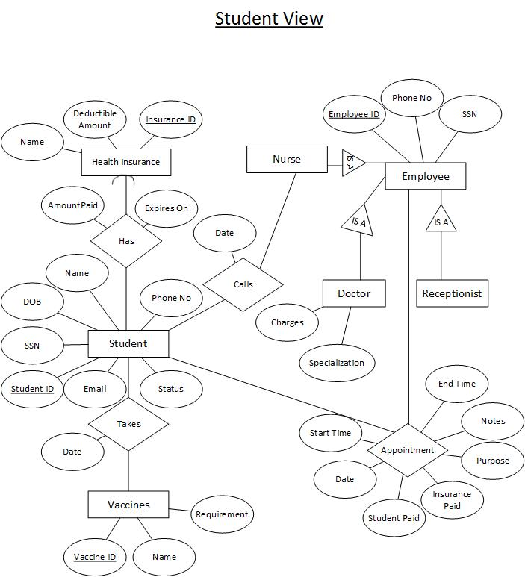

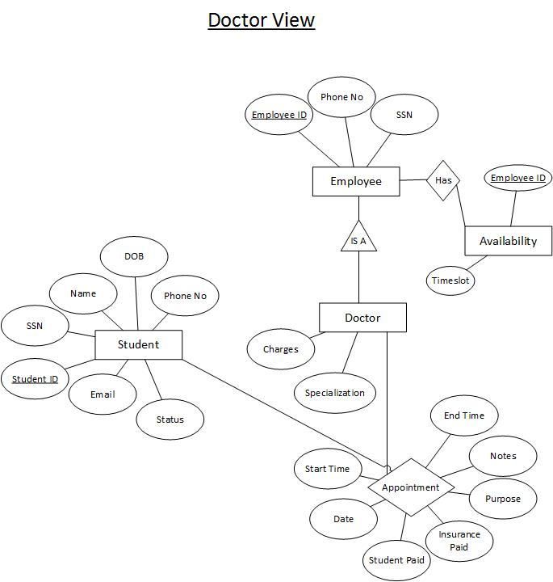

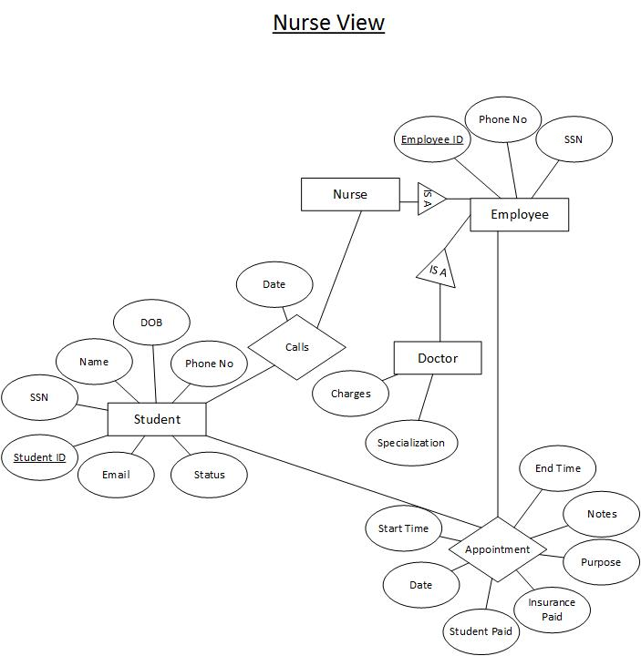

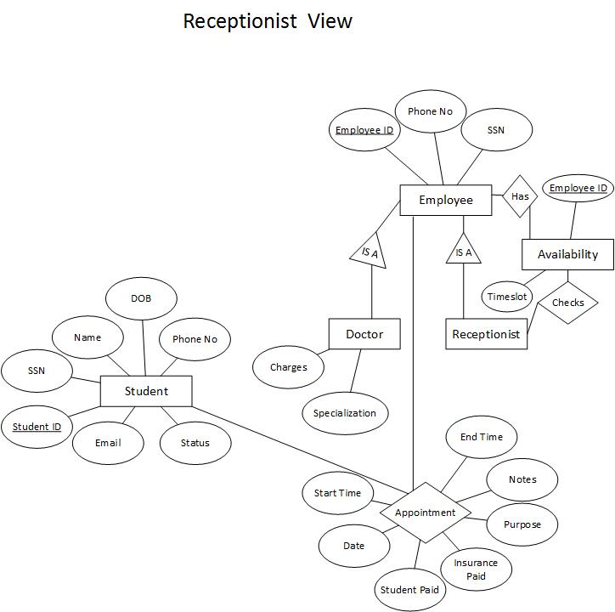

8) Local E/R Documentation

As per our analysis, there are 4 categories of user who intends to use the Reasonable Care system. A brief description of their respective local ER’s are as follows:
- Students :
- Student is the most important entity as they are the main users of this system.
- Student information is stored in the Student Entity set which will all the basic information about the student like Name, SSN, Date of Birth, Email, Phone Number, emergency contact etc.
- Since Student ID assigned to each student is unique, we make the student ID as the primary key.
- We included a status field in the student entity itself to indicate whether the student account is ACTIVE or has been put on HOLD. The value of this attribute is determined by whether the student has taken 3 Vaccines or not by the end of first semester. Using this attribute, the other systems like (Library, Dining etc...) can check student privileges.
- Information regarding all the vaccines is present in the vaccine entity set. Vaccine ID will be the primary key of this entity set. Students are required to take 3 vaccines in the first semester. This information will be stored in ‘takes’ relationship set which includes a Date attribute to indicate the date when the student has the vaccine.
- Information regarding all the possible Health Insurance is present in the Health Insurance Entity Set whose primary key will be ‘Insurance ID’. It has an attribute called ‘Deductible Amount’ which gives the deductible amount for the plan.
- Student is linked to health insurance by ‘has’ relationship which contain ‘Amount Paid’ and ‘Expires On’ attributes. ‘Amount Paid’ attribute is to keep track of the amount the student has paid till now for all his checkups. This field is used to check whether the student has paid the full deductible for his insurance plan or not. If yes, then the student is not billed for the checkup. The entire bill is charged to insurance company. ‘Expires On’ keeps track of when the student health insurance is going to expire. Since a student need to have exactly one health insurance, the relationship between student and Health Insurance entity will be many to one.
- Student appointment information should be accessible to doctors, nurse and receptionist as well. Thus we link ‘Appointment’ relation to the employee superclass itself (instead of linking it with all the three subclasses). Appointment relationship will hold information about all the appointment the student has taken and will provide a complete history about the student past appointments as well.
- Student can call center's same-day-care hotline in order to talk to nurse.

- Doctors :
- Doctor entity is a subclass of employee as it contains specific attributes like specialization and charges.
- Doctor is linked to student via the appointment relationship. This relationship allows the doctors to access student records like basic information, past medical history etc.
- We provides a ‘notes’ attribute which allows the Doctor to make notes for a particular appointment and can save it for future reference.
- Doctors availability is maintained in Availability entity set which will contains the availability information about all the employee.
- Doctor can view their current, future or past appointments (History) using the appointment relationship set.

- Nurse :
- Nurse is responsible for handing center's same-day-care hotline. When a student calls the Nurse, we record the activity in ‘calls’ relationship.
- Nurse availability is also maintained in Availability entity set.
- Nurse can advise student or access the appointment relationship to determine the doctor the student has been seeing and thus can consult the doctor. She can also view student records and appointments.

- Receptionist :
- The receptionist helps the student in booking the appointment. The receptionist will follow the same sequence of steps as a student might follow while booking an appointment using our system.
- Receptionist answers the call of the student and will take necessary details from the student like his ID, purpose etc. He/she then books the appointment of the student.

9) Local Relational Schemas
User classes that our system has are :-
- Student
- Receptionist
- Doctor
- Nurse
We have seen earlier, (in question 7) the local E-R diagrams for each of the above users of the system. We refer to those local E-R diagrams and translate them into our local relational schemas using the E-R Approach.

- Student relational schema :
Student (
student_id , the unique id assigned by the university to every student
name , the name of the student
SSN , the social security number if a student has any
email_id, the email-id of the student
phone_no, the contact phone number of the student
insurance_id) the id of the insurance purchased by the student)

- Employee relational schema :
Employee (
employee_id, the unique id assigned to every employee by the university
phone_no, the contact phone number of the employee
SSN , the social security number if a student has any
)

2.1) Receptionist relational schema:
Receptionist (
employee_id, the unique id assigned to every employee by the university
)

2.2) Doctor relational schema :
Doctor (
employee_id, the unique id assigned to every employee by the university
charges, the fee that the doctor charges for visits
specialization, the field of Doctor’s expertise.
)

2.3) Nurse relational schema :
Nurse (
employee_id, the unique id assigned to employee by the university
)

The above are the intended classes of users of the system. All these users are inter-connected by the following relationships :-

1) hasInsurance relational schema :
hasInsurance (
student_id, the unique id assigned by the university to every student
insurance_id, the unique id for assigned
amount_paid, the amount that the student paid for the insurance
)

2) takesVaccine relational schema :
takesVaccine (
student_id, the unique id assigned by the university to every student
vaccine_id, the unique id used to identify a vaccine
date, the date at which the vaccine was administered
)

3) appointment relational schema :
appointment (
student_id, the unique id assigned by the university to every student
employee_id, the unique id assigned to every employee by the university
start_time, the start time of the appointment
end_time, the end time of the appointment
date, the date of the appointment
student paid the amount that student pays for the doctor’s visit
ins paid the amount that the insurance company pays
purpose the purpose of the visit
notes the doctor’s notes for the visit
)

4) callsNurse
callsNurse (
student_id, the unique id assigned by the university to every student
employee_id, the unique id assigned to every employee by the university
date, the date of the call
)

10) Local Schema Documentation

In case of each of the relational schemas, we have mechanically interpreted each entity set as a relation with the attributes of the entity becoming the columns of the relation.
There are two basic classes of users - Students and Employees. Employee is a super-class of receptionists, doctors and nurses as all these actors have few properties in common including their identifying primary key - employee ID.
We have used the E-R approach on the “is-a” relationship in translating the local E-R diagram to relational schemas. Hence, we only have the primary key of the super-class “employee” visible in all three types of employees along with their local attributes (if any). The reason for choosing E-R approach is to avoid redundancy of same kind of information in all the three types of Employee relations.
All relationships too are made into relations with their attributes being the primary keys of the associated entities along with any attributes they already have.

